**Candidate name:** Adam Hewitt

**Date:** 23/11/2016

**Assignment 1**

**This assignment looks at the project management side of development including gathering requirements through use-cases, mapping use-cases to users and drawing up class diagrams and sequence diagrams.**

**Question 1**

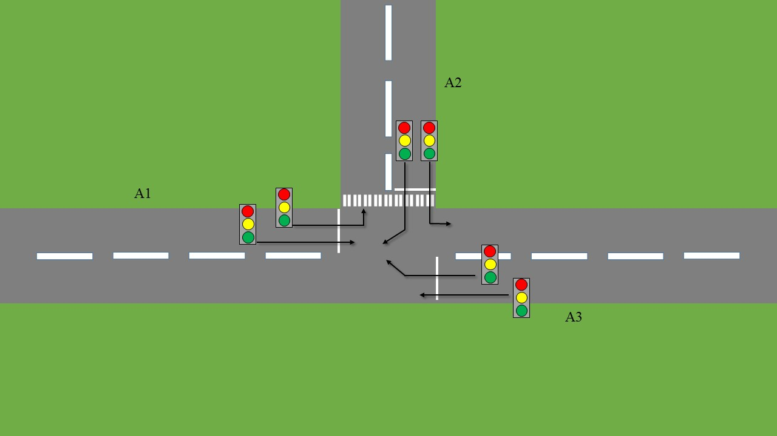

**Requirements**

FR1 - An intersection consists of a meeting of three roads.

FR2 – Vehicle traffic is allowed, in principle, to flow from each road to another.

FR3 – Vehicle traffic lights control the flow between roads A1, A2 and A3.

FR4 – Road A2 has one pedestrian traffic crossing. The other roads have none.

FR5 – At any point in time, the pedestrian traffic light on road A2 is in either state: red or state: green.

FR6 – At any point in time, each vehicle traffic light is in either one of the following states: green, amber or red.

FR7 – Each traffic light may receive only one of the following signals from the intersection: Open or Close.

FR8 - Each traffic light that is red and received an Open signal should become red-amber and a second later; turn green. Vice versa -each traffic light that is green and receives a Close signal should turn amber and a second later, turn red.

FR9 – A pedestrian traffic light that is green and received a Close signal from the intersection should change into red. If Red and received an Open signal it should change to green.

**Question 2**

**Use-Cases Analysis**

There are three major use-cases in my use-case analysis; Automated System; Change Lights (vehicle) and Change Lights (Pedestrian). Each one has its own use-case diagram.

**Use-Cases**

Automated System

* Change Lights (vehicle)
  + Lights on other side change to opposite of current state [FR7, FR8]
  + Allow single lane traffic [FR2, FR3, FR6]
  + Stop single lane traffic [FR2, FR3, FR6]
  + Allow left lane traffic [FR2, FR3, FR6]
  + Allow right lane traffic [FR2, FR3, FR6]
  + Stop left lane traffic [FR2, FR3, FR6]
  + Stop right lane traffic [FR2, FR3, FR6]
* Change Lights (pedestrian)
  + Pedestrian crosses (green) [FR4, FR5, FR9]
  + Pedestrian waits (red) [FR4, FR5, FR9]

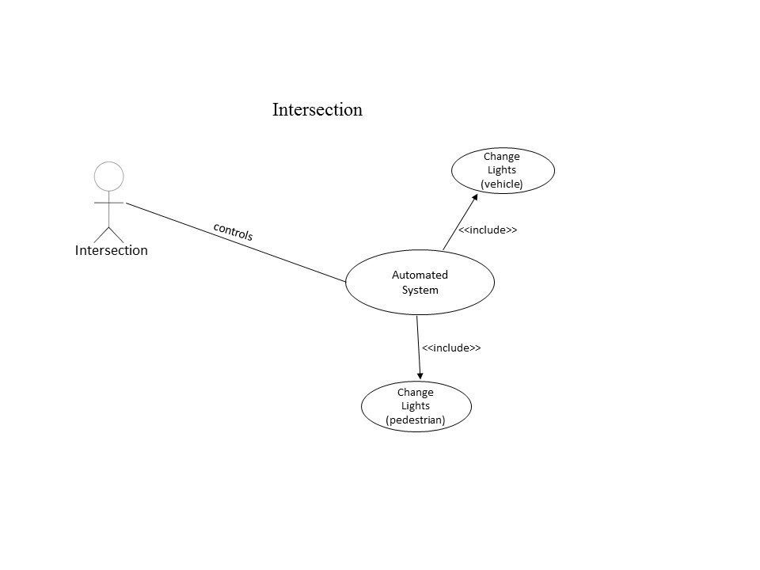

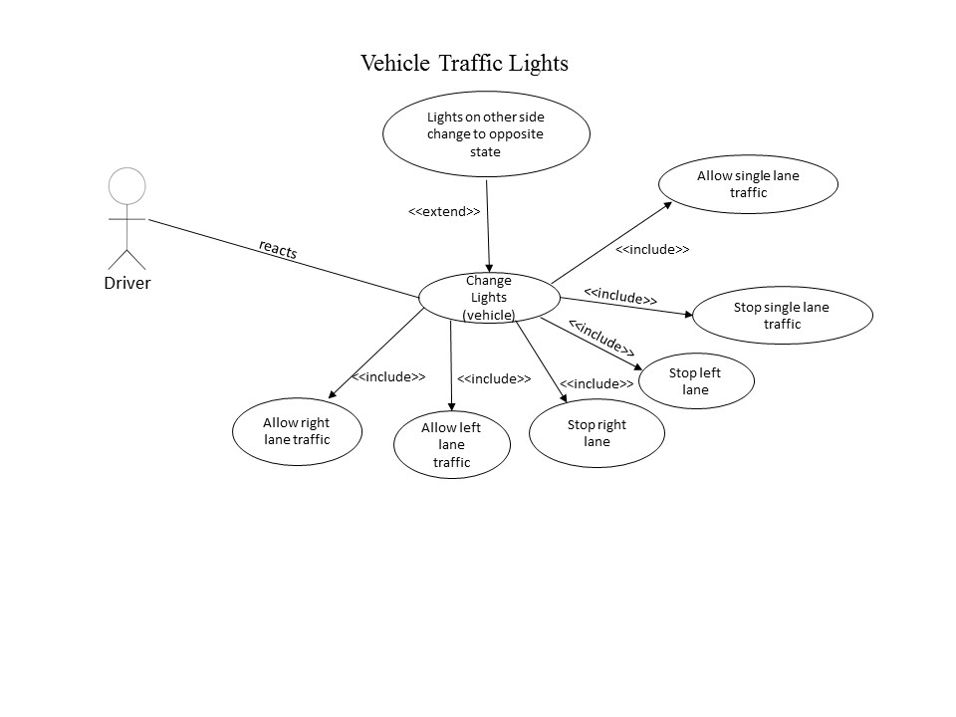

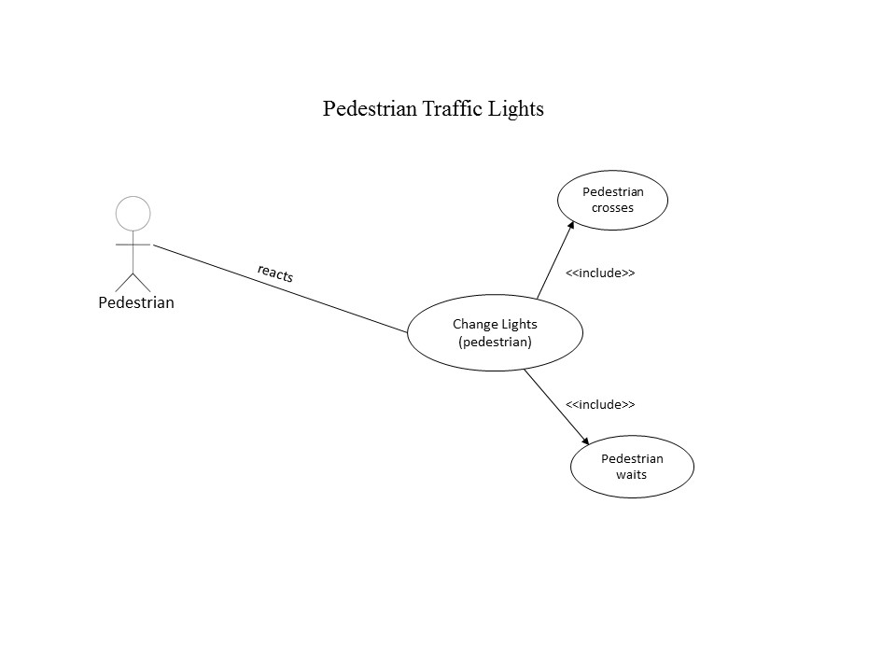

**Question 3**

**Class-Responsibility-Collaborations**

|  |  |
| --- | --- |
| **Class Name:** Vehicle Traffic Light | |
| **Responsibilities** | **Collaborations** |
| Receive open or close signal | Intersection (send signals)  Road (ingoing, outgoing) |

|  |  |
| --- | --- |
| **Class Name:** Driver | |
| **Responsibilities** | **Collaborations** |
| Stop or continue | Vehicle Traffic Light (change lights)  Road (left, right, straight ahead) |

|  |  |
| --- | --- |
| **Class Name:** Pedestrian | |
| **Responsibilities** | **Collaborations** |
| Wait at lights or cross the road | Pedestrian Traffic Light (change lights)  Pedestrian Crossing |

|  |  |
| --- | --- |
| **Class Name:** Pedestrian Traffic Light | |
| **Responsibilities** | **Collaborations** |
| Wait for pedestrian to press button  Send open or close signal | Intersection (send signals)  Road (ingoing, outgoing)  Pedestrian (press button) |

**Question 4**

**Type Diagram**

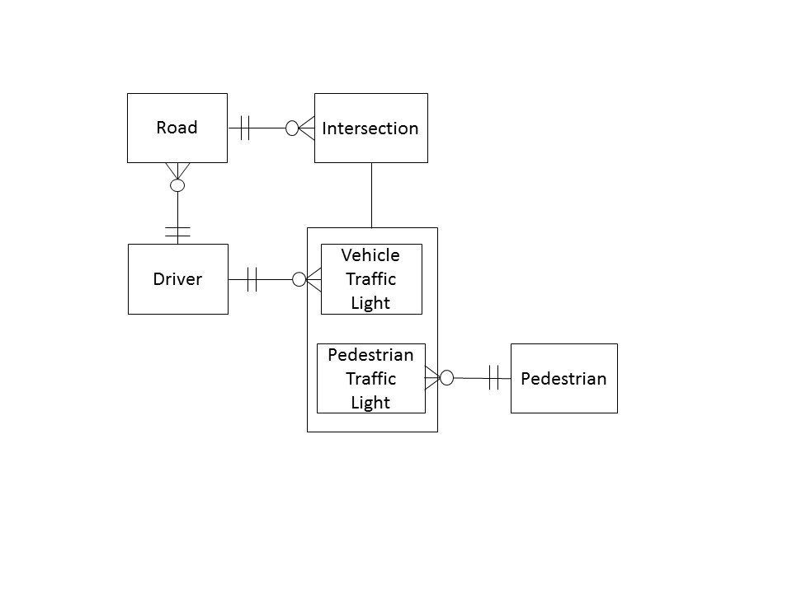

The type diagram addresses a few of the requirements. These requirements are as follows.

FR1 – The Intersection consists of a meeting of three roads. The above diagram shows that the Intersection type links with the Roads type with a ‘has a’ relationship.

FR2 – This is shown in the fact that the Driver type is linked to both the Vehicle Traffic Light type AND the Road type.

FR3 – Traffic (defined as Drivers) is controlled through the Vehicle Traffic Light type.

FR4 – This is shown in the diagram as the Pedestrian Type is linked to Pedestrian Traffic Light which is in turn linked to the Intersection.

FR5 – This isn’t shown in the type diagram as it is a specific behaviour of the Traffic Light types.

FR6 - This isn’t shown in the type diagram as it is a specific behaviour of the Traffic Light types.

FR 7 - This isn’t shown in the type diagram as it is a specific behaviour of the Traffic Light types.

FR 8 - This isn’t shown in the type diagram as it is a specific behaviour of the Traffic Light types.

FR 9 - This isn’t shown in the type diagram as it is a specific behaviour of the Traffic Light types.

**Question 5**

Below is a list of all of the configurations the traffic lights will be in during the operation of the system.

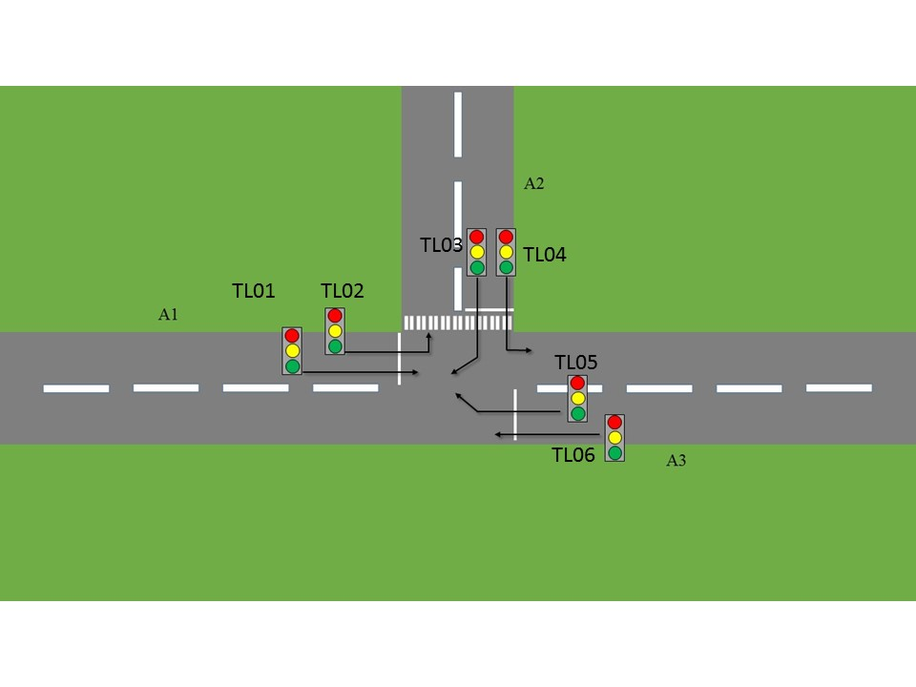

|  |
| --- |
| **Traffic Light States – Config 1 (left turn at A1)** |
| TL01 is green |
| TL02 is green |
| TL03 is red |
| TL04 is green |
| TL05 is red |
| TL06 is green |

|  |
| --- |
| **Traffic Light States – Config 2 (right turn at A2)** |
| TL01 is red |
| TL02 is green |
| TL03 is green |
| TL04 is green |
| TL05 is red |
| TL06 is red |

|  |
| --- |
| **Traffic Light States – Config 3 (right turn at A3)** |
| TL01 is red |
| TL02 is green |
| TL03 is red |
| TL04 is green |
| TL05 is green |
| TL06 is green |

|  |
| --- |
| **Traffic Light States – Config 4 (pedestrian crossing)** |
| TL01 is green |
| TL02 is red |
| TL03 is red |
| TL04 is red |
| TL05 is red |
| TL06 is green |

In regards to the changing of configuration, let’s assume the system is in configuration 1 and needs to be switched to configuration 2 to allow for traffic flow. In the above tables, when comparing Config 1 to Config 2, TL01 will turn from green to amber to red. TL03 will turn from red to red-amber and then green.

**Sequence Diagram**

Candidate Objects

* Intersection (automated control)
* Driver
* Pedestrian
* ChangeLights(vehicle)
* ChangeLights(pedestrian)

